Location details for consultations at Krysallis Therapy Rooms;
Krysallis Therapy Rooms (blue door in the bottom photo)

5 Victoria Avenue
Harrogate
Harrogate Bus and Train Stations: 5 minute walk away
HG1 1EQ

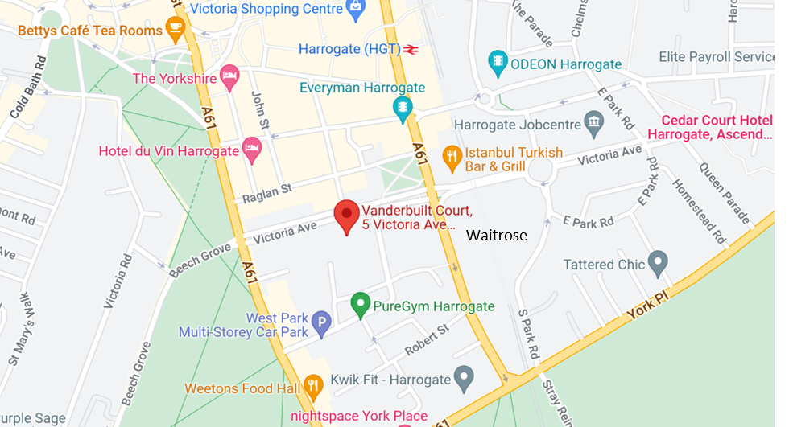
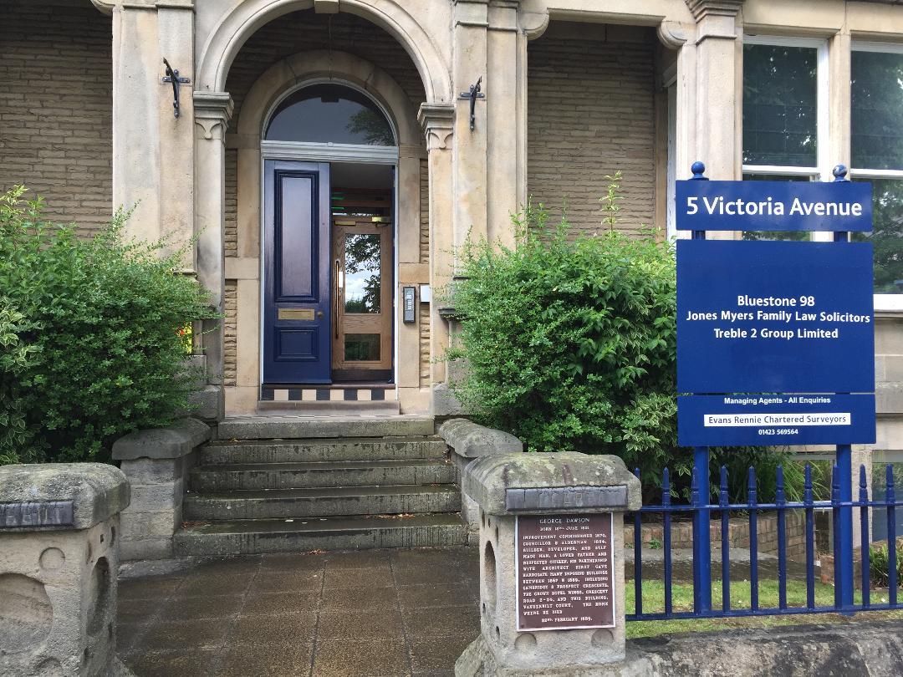

For any assistance, please call Rebecca: 07584 119252.
If you have particular access requirements, please get in touch to discuss alternative arrangements.

